Version 5.0

Task 0: Explain what you are doing/ going to accomplish

In this version I am going to improve the design of the website, as well as fix any bugs I come across. This is a minor update.

Task 1: Sketch interface design

Not applicable for this version, no new pages created.

Task 2: Identify any classes required

N/A

Task 3: Identify information to be displayed

N/A

Task 4: Identify user inputs

N/A

Task 5: Identify any constants or existing data if required

No constants for this version

Task 6: Identify indexed data structures

N/A

Task 7: Determine what calculations are necessary

No calculations needed in this version

Task 8: Develop a modular structure for your program

No python needed in this version, unless I come across bugs

Task 9: Define the functions identified

None

Task 10: Address any relevant implications such as usability, functionality, legal/ethical requirements.

Within this version, I will need to create a website interface that is easy to read and simple to understand as many of the users may be older/unfamiliar with technology. I also need to follow the general rules of design when it comes to websites with colours layout etc. Buttons need to be clear and laid out, everything should make sense.

It need to be functional, it should first fufill its purpose and secondly look aesthetically pleasing,

No copyrighted images. No illegal or explicit images etc.

This version especially will be me trying to fix up the website and making sure everything is aligned, similar theme and design.

Task 11: Document test cases for testing the program

N/a (make sure all pages load correctly)

Task 12: Refine the plan

I realised that adding a new dog did not have the option for gender, which I had forgotten to add. The python code was returning None as I had not specified it within the form.

I added in the gender form and now it works as shown.



Here you can see that the gender shows up on the new dogs ID card on the showcase page. This is merely a test example.

I thought about the revelant forms for a dog and realised that there was no age cap. The dog could be from (-infinty, infinity) to change this I set the min age to be 1, as well as the max age to be 30. I chose 1 as the minimum age in years as a puppy under 1 year old is unlikely to be rented out on a doggy site. They would require too much care. And 30 was the max as I googled the oldest dog to live and it was 30 years old. (<https://dogtime.com/trending/37499-worlds-oldest-dog-dies-peacefully-age-30>) So I added this code into the input form for age.

Max=”30” Min = “1”.

Testing.

I then wanted to test these cases with different boundary values

|  |  |  |
| --- | --- | --- |
| Input Age | Expected output | Actual Output |
| 0 | No | No |
| 1 | Yes | Yes |
| 15 | Yes | Yes |
| 30 | Yes | Yes |
| 31 | No | No |

In this case “No” is when the program does not allow the input through, while “Yes” is when the input is allowed

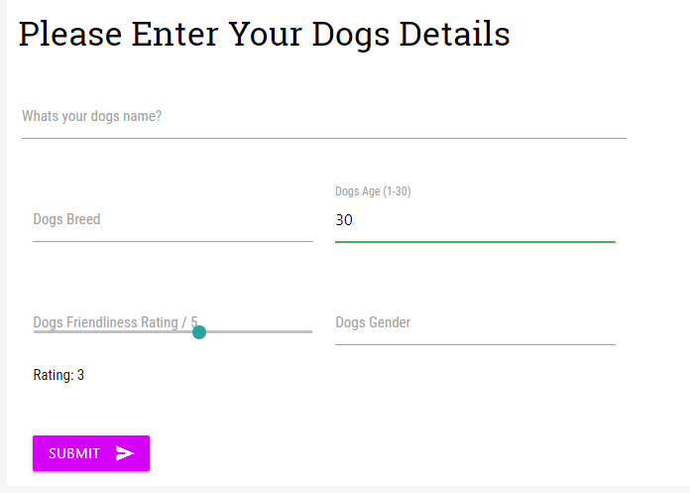

This is the “Yes” case, the green line indicates it is a valid input.

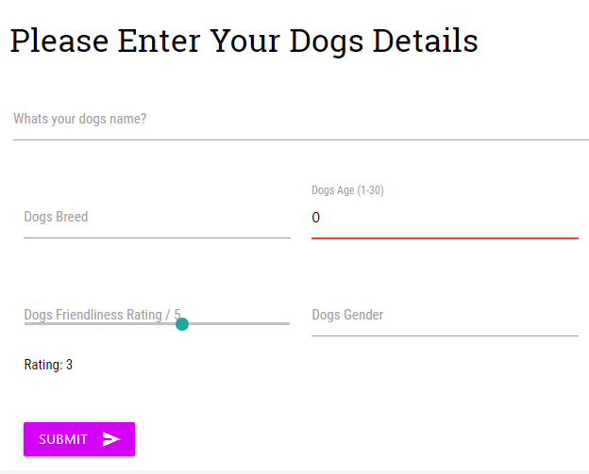

This is a “No” case. The red line indicates it is an invalid input.

Task 13: Document testing

N/A (bugs above are shown tested above)

Task 14: Evaluation